PowerShell Developer Guide
2022
Judele, Daniel
1/31/2020
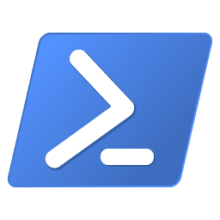
Contents
1 PowerShell 2
2 Getting started 3
2.1 Set up development environment 3
2.1.1 Install Visual Studio Code 3
2.1.2 Install PowerShell extension for Visual Studio Code 3
2.1.3 Install PSScriptAnalyzer 4
2.1.4 Install Pester 4
2.1.5 Settings 4
3 Development Guidelines 5
3.1 Scripts 5
3.1.1 Script naming convention 5
3.1.2 Function naming convention 5
3.2 Modules 5
3.2.1 Register default repository for PowerShell Modules 5
3.2.2 Script Modules 6
4 Debugging script in Visual Studio 7

PowerShell
PowerShell is a task-based command-line shell and scripting language built on .NET.
PowerShell helps system administrators and power-users rapidly automate tasks that manage operating systems (Linux, macOS, and Windows) and processes.
Here is the official documentation.
PowerShell is open source, here is the source code.

Getting started

Set up development environment
To set up development environment install the following tools:
- Code Editor: Visual Studio Code
- Extensions:
  - PowerShell extension for Visual Studio Code
- Code analyzer: PSScriptAnalyzer
- Unit tests: Pester

Install Visual Studio Code
Install Visual Studio Code based on operating system.
Here you can find more information about setup Visual Studio code for PowerShell development.
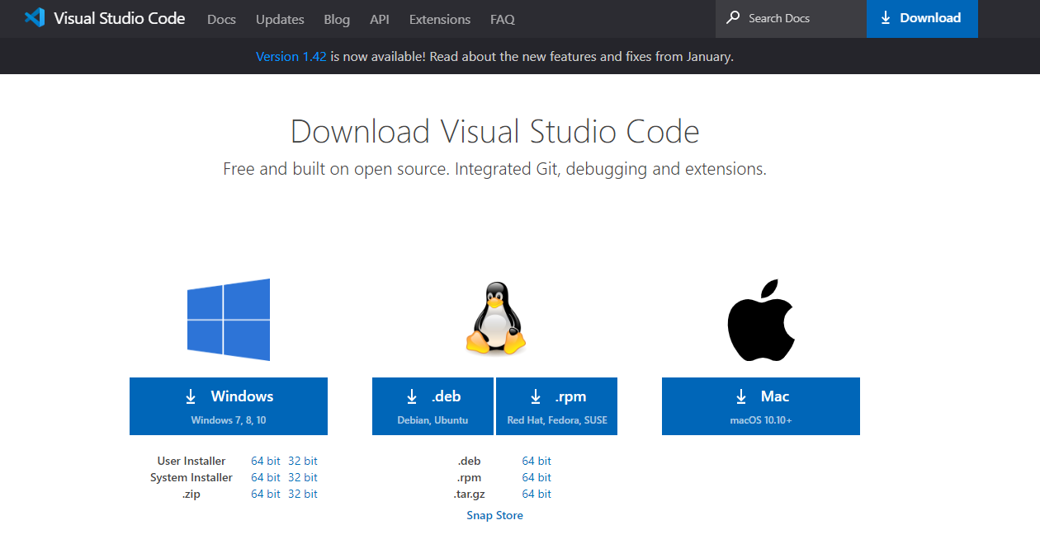

Install PowerShell extension for Visual Studio Code
The PowerShell extension was created by Microsoft to develop PowerShell scripts in Visual Studio.
You can also install the PowerShell extension from within Visual Studio Code by opening the Extensions view with keyboard shortcut Ctrl+Shift+X and typing "PowerShell" and select the PowerShell extension
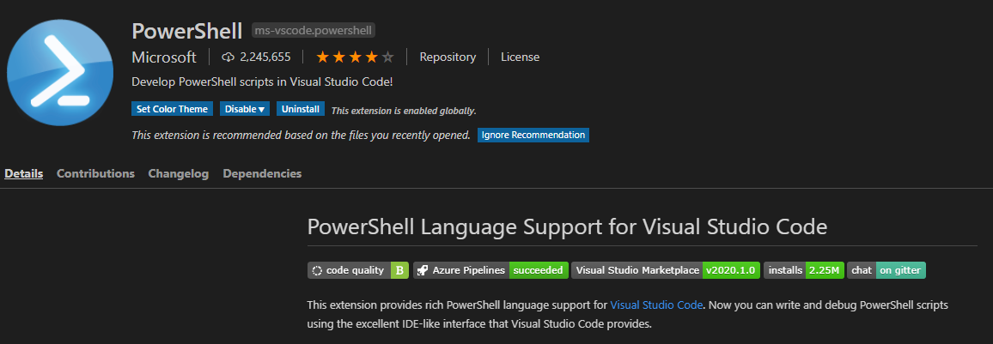

Install PSScriptAnalyzer
Install PSScriptAnalyzer and configure only if you don’t use PowerShell extension from Microsoft.
The PowerShell extension includes PSScriptAnalyzer by default, and automatically performs analysis on PowerShell script files being edited in Visual Studio Code.
Here you can find more information about the integration with Visual Studio Code.
https://devblogs.microsoft.com/scripting/visual-studio-code-editing-features-for-powershell-development-part-2/

Install Pester
Pester is a Behavior-driven Development (BDD) based unit test runner for PoweraShell.

Settings

Execution policy
Here you find more information about execution policies.
By default, for Windows clients, the execution policies is set to Restricted. That means is not possible to load configuration files or run scripts.
The following error occurs when you run a script and the the execution policies is set to Restricted.
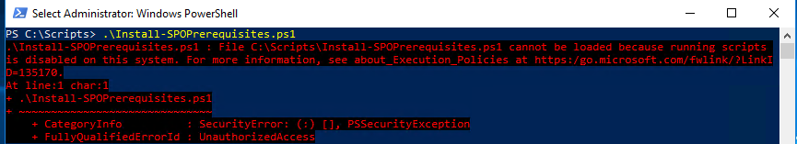
Run the following command in Command Prompt (cmd.exe) window to change the execution policy:
powershell Set-ExecutionPolicy Unrestricted

Development Guidelines

Scripts

Script naming convention
Verb-Noun.ps1
Samples: Export-SiteCollumns.ps1
Use the same verbs as Microsoft. To get all the verb you can run the command: Get-Verb
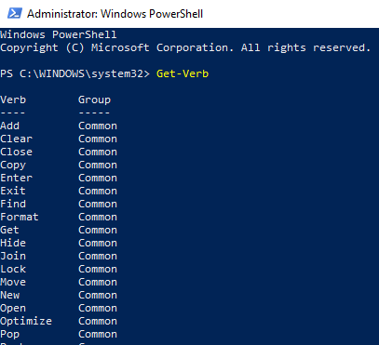
Here are more details about the development guidelines recommended by Microsoft.

Function naming convention
The same as 3.1.1

Modules

Register default repository for PowerShell Modules
By default, powershell gallery location is set as default repository.
Use Get-PSRepository to get the powershell modules repositories.
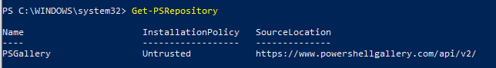
Use Register-PSRepository to register a PowerShell repository.

Script Modules
Here you can find more information about how to write a PowerShell module.
Create a basic PowerShell module.
- Save a PowerShell script with a .psm1 extension. Use the same name for the script and the directory where the script is saved.
- To control user access to certain functions or variables, call Export-ModuleMember at the end of your script.
- If you have modules that your own module needs to load, you can use Import-Module, at the top of your module.
- To describe your module to the PowerShell Help system, you can either use standard help comments inside the file, or create an additional Help file. For more information, see Writing Help for Windows PowerShell Modules.

Here you can find more information about how to create a local repository and to register a module.

Debugging script in Visual Studio

https://devblogs.microsoft.com/scripting/debugging-powershell-script-in-visual-studio-code-part-2/

